# [cid:image001.png@01D4E55A.4DECF820](http://www.comviva.com/)

Photograph

**Employment Application Form**

|  |  |  |  |  |  |  |  |  |  |  |  |  |  |  |  |  |  |  |  |  |  |  |  |  |
| --- | --- | --- | --- | --- | --- | --- | --- | --- | --- | --- | --- | --- | --- | --- | --- | --- | --- | --- | --- | --- | --- | --- | --- | --- |
| **First Name** | | | | | | | Yajash | | | | | | | | | | | | | | | | | |
| **Middle name** | | | | | | |  | | | | | | | | | | | | | | | | | |
| **Last Name** | | | | | | | Goplani | | | | | | | | | | | | | | | | | |
|  | | | | | | | | | | | | | | | | | | | | | | | | |
| **Gender** | | | | | | | **Male** | | | | | | | | | | | | | | | | | |
| **Nationality** | | | | | | | Indian | | | | | | | | | | | | | | | | | |
|  |  |  |  |  |  |  | |  | |  | |  | |  | |  | |  | |  | |  |  |  |
| **Date Of Birth (DD/MM/YYYY)** | | | | | | |  | 2 | 8 | |  | | 0 | | 2 | |  | | 2 | | 0 | | 0 | 0 |

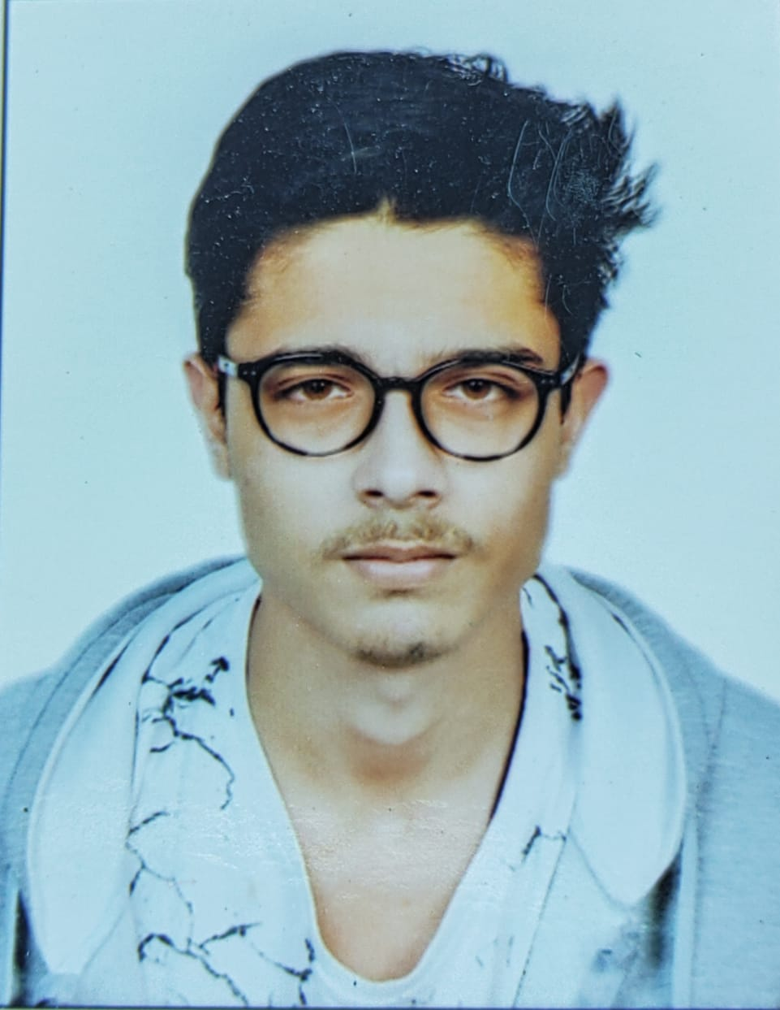

|  |  |  |
| --- | --- | --- |
| **PERMANENT**  **ADDRESS** | **LINE 1** | A-30-D, DSIDC flats |
| **LINE 2** | Paschim puri |
| **LINE 3** |  |
| **CITY** | New Delhi |
| **STATE** | Delhi |
| **COUNTRY** | India |
| **PIN CODE** | 110063 |
|  | | |
| **CORRESPONDENCE**  **ADDRESS (only if different from permanent address)** | **LINE 1** | A-30-D, DSIDC flats |
| **LINE 2** | Paschim puri |
| **LINE 3** |  |
| **CITY** | New Delhi |
| **STATE** | Delhi |
| **COUNTRY** | India |
| **PIN CODE** | 110063 |

|  |  |  |  |  |  |  |  |  |  |  |  |  |  |  |  |  |  |
| --- | --- | --- | --- | --- | --- | --- | --- | --- | --- | --- | --- | --- | --- | --- | --- | --- | --- |
| **CONTACT**  **DETAILS** | **MOBILE** | 7 | 0 | 4 | 2 | 4 | 2 | 5 | 5 | 4 | 5 |  |  |  |  |  |  |
| **LANDLINE** |  |  |  |  |  |  |  |  |  |  |  |  |  |  |  |  |
|  | **COUNTRY/STATE CODE** | | | | | | **NUMBER** | | | | | | | | | |
|  | | | | | | | | | | | | | | | | |
| **PRIMARY EMAIL ID** | yajash.goplani@gmail.com | | | | | | | | | | | | | | | |
| **SECONDARY EMAIL ID** | gyajash@gmail.com | | | | | | | | | | | | | | | |

|  |  |  |  |  |  |  |
| --- | --- | --- | --- | --- | --- | --- |
| **Educational Qualification (write NA wherever not applicable)** | **Qualification** | **University/Board/Institute** | **Specialisation/Stream** | **Month and year of Starting (MM/YYYY)** | **Month and year of Ending (MM/YYYY)** | **CGPA/%age** |
| **Xth** | **Lt Col Mehar Little Angels Sr Sec School** | **CBSE** | **04/2014** | **05/2015** | **7.4** |
| **XIIth** | **Lt Col Mehar Little Angels Sr Sec School** | **Science(Non-Med)** | **04/2016** | **05/2017** | **83.67** |
| **Graduation** | **Maharaja Surajmal Institute of Technology** | **BTech** | **08/2017** | **08/2021** | **9.023** |
| Choose an item. |  |  |  |  |  |
| **Any additional qualifications (if)** |  |  |  |  |  |  |
|  |  |  |  |  |  |

|  |  |  |  |  |  |
| --- | --- | --- | --- | --- | --- |
| **Work**  **Experience (Chronological order-please start from the most recent work assignment)** | **Organisation** | **Designation** | **Month and year of Joining (MM/YYYY)** | **Month and year of Leaving (MM/YYYY)** | **No. of months** |
|  |  |  |  |  |
|  |  |  |  |  |
|  |  |  |  |  |
|  |  |  |  |  |
| **Total Work Experience** excluding breaks **(in number of months)** 🡪 | | |  | |

|  |  |
| --- | --- |
| **CURRENT CTC (INR)** |  |
| **EXPECTED CTC (INR)** |  |
| **LEAD TIME TO JOIN (in no. of days)** |  |

|  |  |
| --- | --- |
| **Please mention your latest performance rating in your current/ most recent organization** | Choose an item. |
| **Please mention your class Ranking in the most recent education** | **Top 11-20%** |

|  |  |  |  |  |  |
| --- | --- | --- | --- | --- | --- |
| **Do you hold a valid passport?** |  | **Yes** |  | **No** |  |
| **Have you ever been denied a visa to any country?** |  | **Yes** |  | **No** | If yes, please explain |
| **Have you at any time been convicted of a crime?** |  | **Yes** |  | **No** | If yes, please explain |
| **Are any criminal proceedings pending against you before any Court?** |  | **Yes** |  | **No** | If yes, please explain |
| **Have you ever been involved in, supported or encouraged terrorist activities in any country?** |  | **Yes** |  | **No** | If yes, please explain |
| **Have you ever been a member of, or given support to an organization that has been concerned in terrorism?** |  | **Yes** |  | **No** | If yes, please explain |

|  |  |
| --- | --- |
| **Signature and certification** | |
| 1. **I certify that all of the information on and attached to this application is true, correct, complete and made in good faith. I understand that false or fraudulent information on or attached to this application may be grounds for not hiring me, or for termination/dismissal after I begin work. I understand that any information I voluntarily provide on or attached to this application may be investigated.** 2. **Submission of employment application form in no way guarantees my selection at Comviva Technologies Limited for the Position to which I have applied. This is the first step to consideration of my candidature.** 3. **Comviva Technologies Limited reserves the right to place me in any of their facilities purely basis the business requirement and my profile match to the same.** | |
| **Date (DD/MM/YYYY)** |  |
| **Place** |  |
| **Signature** |  |